4-1 Milestone: Create and Read in Python

Cristiano Miranda
Southern New Hampshire University
CS-340: Client/Server Development
Professor Badam
29 March 2026

4-1 Milestone: Create and Read in Python
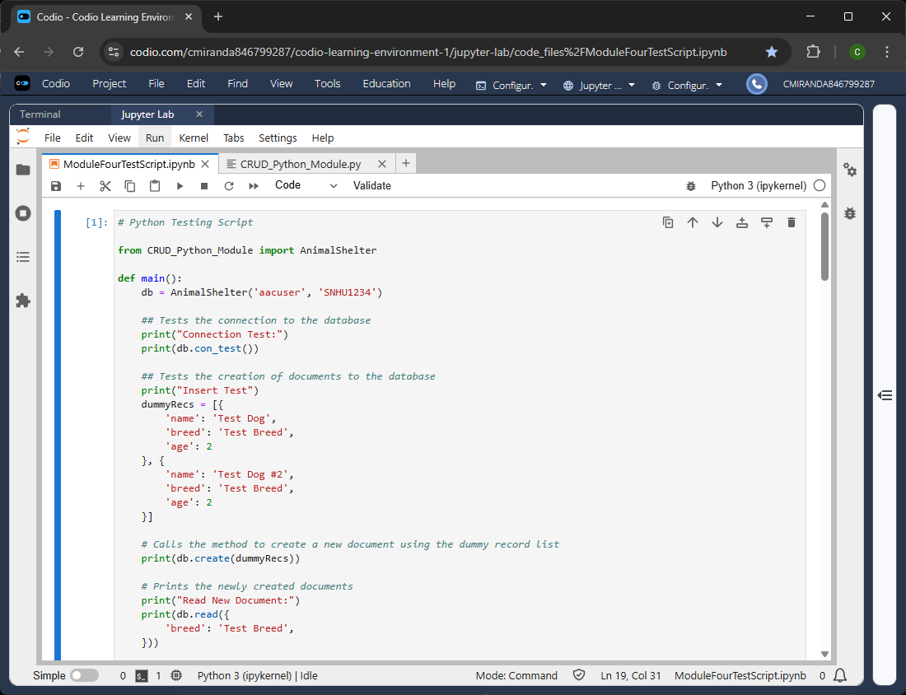
Figure 1 – Creation Test Code for Validating the Creation Method from the Python CRUD module

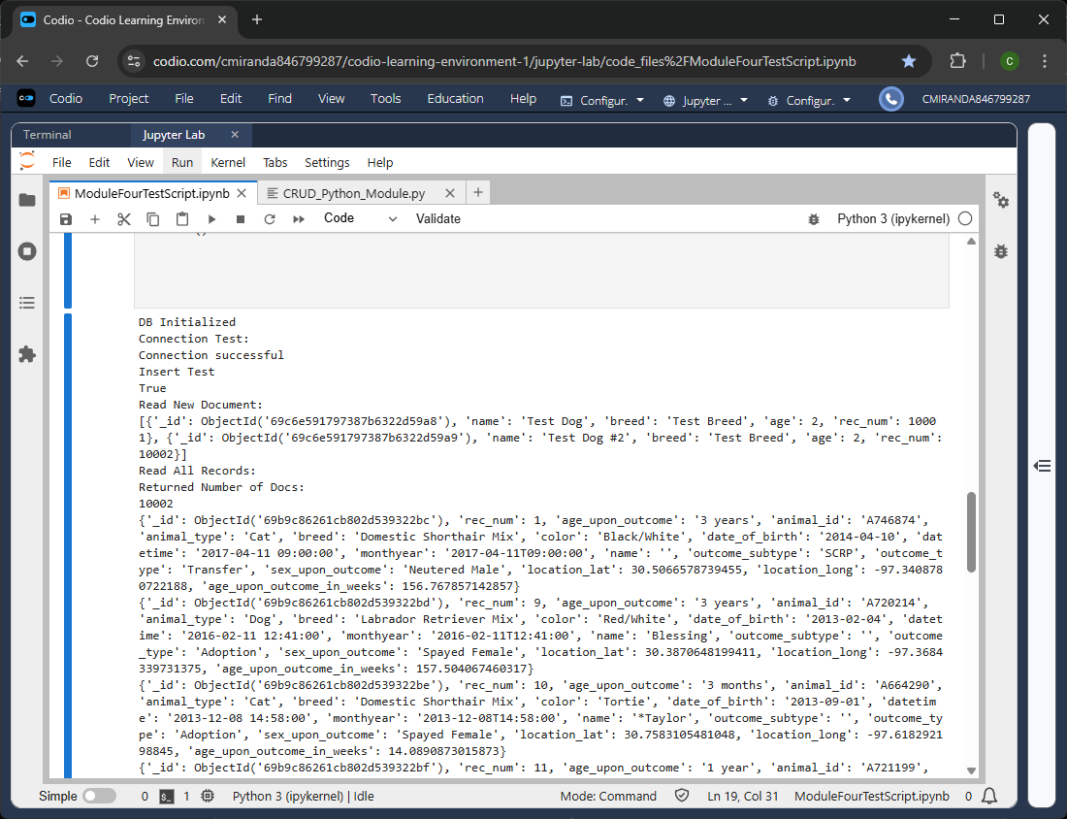
Figure 2 – Creation Test Output that validates that the creation method was successful and the new document was accessible from the database
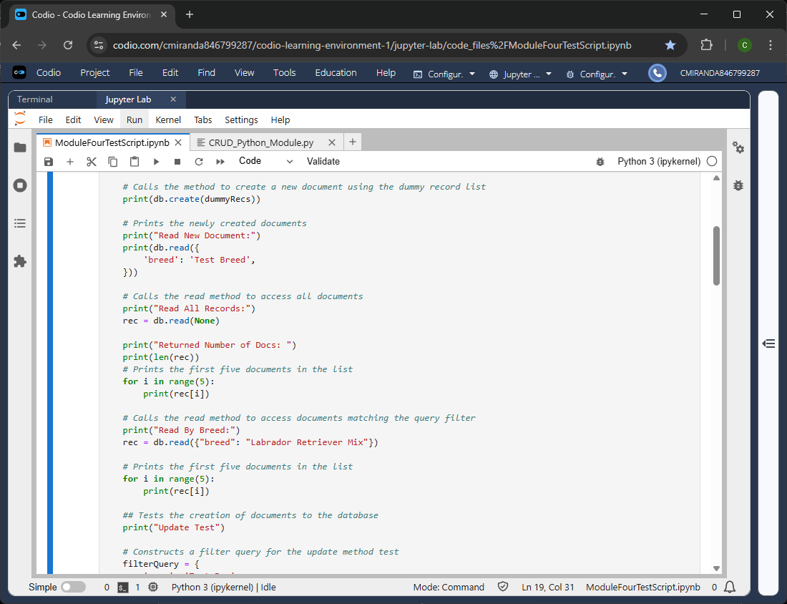
Figure 3 - Read Test Code for Validating the Read Method from the Python CRUD module
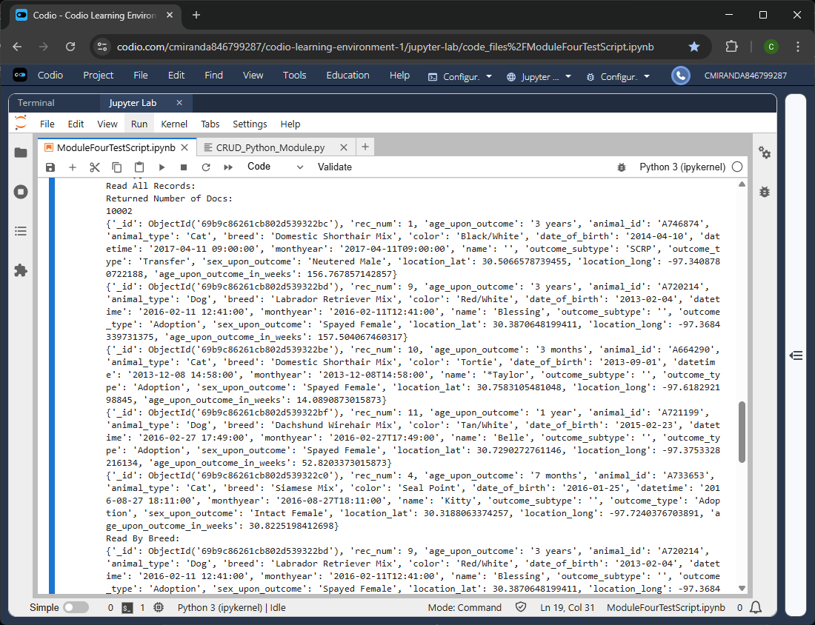
Figure 4 – Read Test Output that validates that the read method was successful and that all the returned number of records matches the total number of records from the database’s collection, but only the first five are shown.
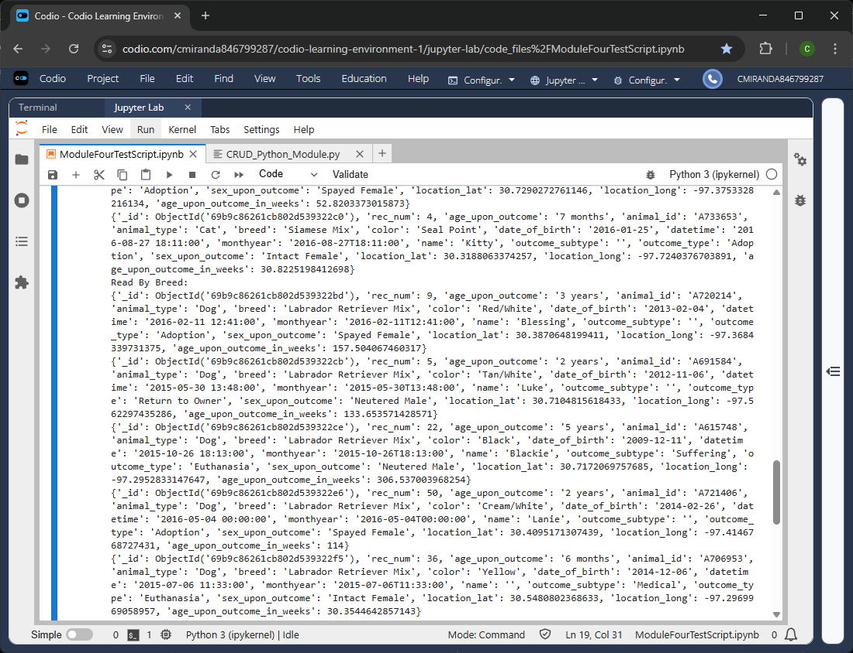
Figure 5 – Read Test Output that validates that the read method was successful in using the passed in query filter to filter the database’s collection. Only the first five records are shown again, but in comparing them to the first five records obtained from reading the entire database, they are different and all match the passed in filter query.

